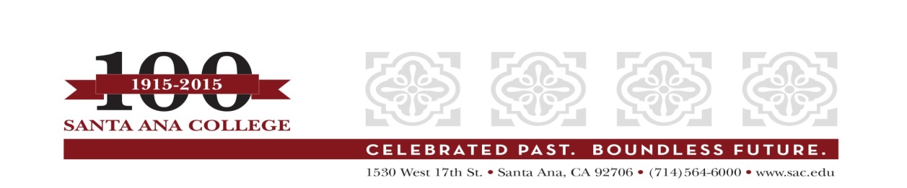
CSEA Classified Staff Meeting
Minutes
June 8, 2015
Mission: The mission of the Rancho Santiago Community College District is to provide quality educational programs and services that address the needs of our diverse students and communities.
The mission of Santa Ana College is to be a leader and partner in meeting the intellectual, cultural, technological and workforce development needs of our diverse community. Santa Ana College provides access and equity in a dynamic learning environment that prepares students for transfer, careers and lifelong intellectual pursuits in a global community.
Vision Themes of Santa Ana College: I. Student Achievement; II. Use of Technology; III. Innovation; IV. Community; V. Workforce Development; VI. Emerging American Community

Members Present: Sheri Bagdonas, Claudia Figueroa, Susan Gibson, Terry Grijalva, Caroline McCabe, Jimmy Nguyen, Quynh Nguyen, Brenda Ortiz, Maria Taylor, Virginia Witmer

Guests: Bonita Jaros

- Review of the Draft Follow-Up Report:
The purpose of this meeting is to inform the classified staff members regarding the progress of the accreditation Follow-Up Report due to ACCJC (Accreditation Commission for Community and Junior Colleges) October 2015. The draft Follow-Up Report was presented at the meeting. Jimmy Nguyen introduced Bonnie Jaros to the group. Bonnie explained the entire accreditation process to the group. She mentioned that The ACCJC team visited our college October 9-12, 2014, and Santa Ana College received an external evaluation report dated November 19, 2014 with commendations and recommendations for the college. Succeeding that report, Santa Ana College was issued the official Commission disposition in a letter dated February 6, 2015: Reaffirm Accreditation with a Follow-Up Report due by October 15, 2015. Santa Ana College was issued three recommendations as follows
Recommendation 1 – In order to meet the Standards, the team recommends that the college institutionalize a process with identified responsibility that ensure that integration, assessment, analysis and use of assessment results, and documented dialogue of learning outcomes. Learning outcomes include course learning outcomes, program learning outcomes, student services outcomes, administrative unit outcomes, and institutional learning outcomes. (Standards I.B.1, I.B.2, I.B.3, I.B.5, I.B.6, I.B.7, II.A.1.c, II.A.2.a, II.A.2.e, II.A.2.f, II.A.6, II.A.6.c, II.B.4, II.C.2, III.C.2, III.D.4, IV.A.5, IV.B.2.b, IV.B.3.g)
Recommendation 2 - In order to meet the Standards, the team recommends that the College establish, implement, and document a regular cycle of evaluation to include effectiveness of planning processes, training, decision-making, communication, resource allocation, and governance practices. (Standards I.B.3, I.B.6, I.B.7, II.A.6.c, III.C.2, III.D.4, IV.A.5, IV.B.3.g)
Recommendation 3 - In order to meet the Standards, the team recommends that the College make public all student learning outcomes for programs, certificates, and degrees, and ensure and document the regular cycle of assessment of all courses and programs in support of continuous quality improvement. (Standards II.A.1.c, II.A.2.a, II.A.2.e, II.A.2.f, II.A.6)
Under each of the recommendations, there is a breakdown of standards, actionable improvement plans, recommended lead(s) and status. Since this is a draft report, Bonnie would like the classified staff members to review, and if they have any questions, they can call or email her.
Maria Taylor asked what will happen after the Follow-Up Report is submitted. Bonnie replied that ACCJC receives the report in October 2015, the Commission meets in February 2016 and issues its dispensation shortly thereafter.
A more complete draft will be posted for the college community to review and give input, and the final version will be completed at the end of July and approved by all constituency groups and College Council in August. A CSEA Representative will certify and sign the report, along with the College President and representatives from other areas. The Board of Trustees will receive the report for approval in early September. (Please see the Accreditation Oversight Committee minutes at: http://www.sac.edu/AcademicAffairs/IEA_Office/Pages/Accreditation-Oversight-Committee.aspx for updates.)
Respectfully submitted,
Jimmy Nguyen
Classified Staff Representative,
Accreditation Oversight Committee

jn/06-11-15

